Lab 3 : To become familiar with Document based Databases using Cassandra

1. Perform the lab manual as described, make tables, insert data and take snapshots of your practice on Cassandra

End result :

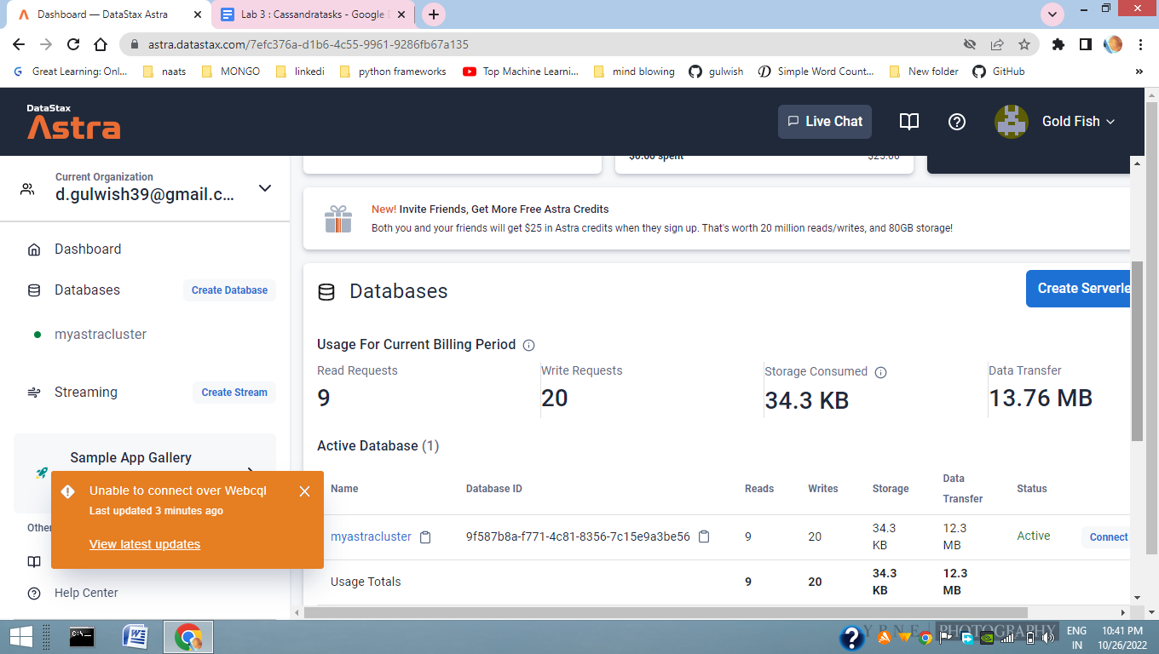

## **1. Create your Astra DB instance\**

| **Parameter** | **Value** |
| --- | --- |

| Database name | mycluster |
| --- | --- |
| Keyspace name | Space craft |

## **2. Create tables**

Navigate to the CQL Console and login to the database

Type command :use <keyspace>

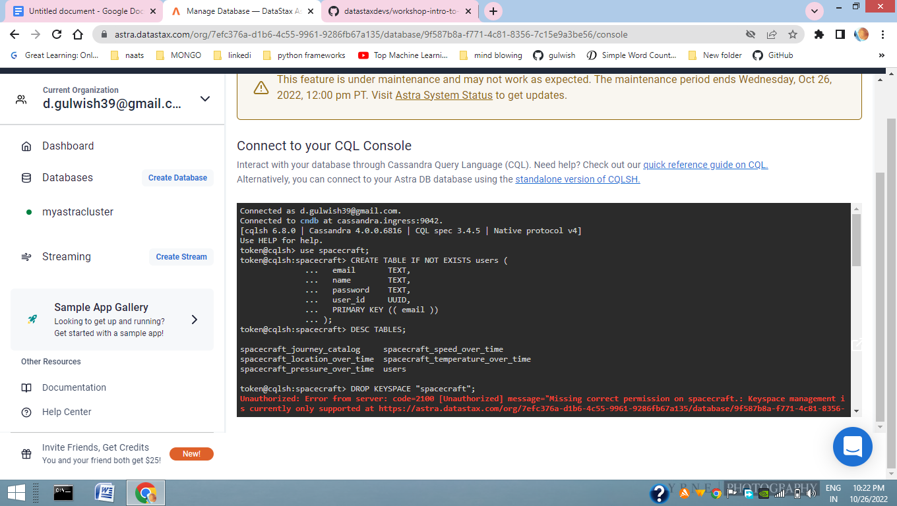

To Check all tables are created:

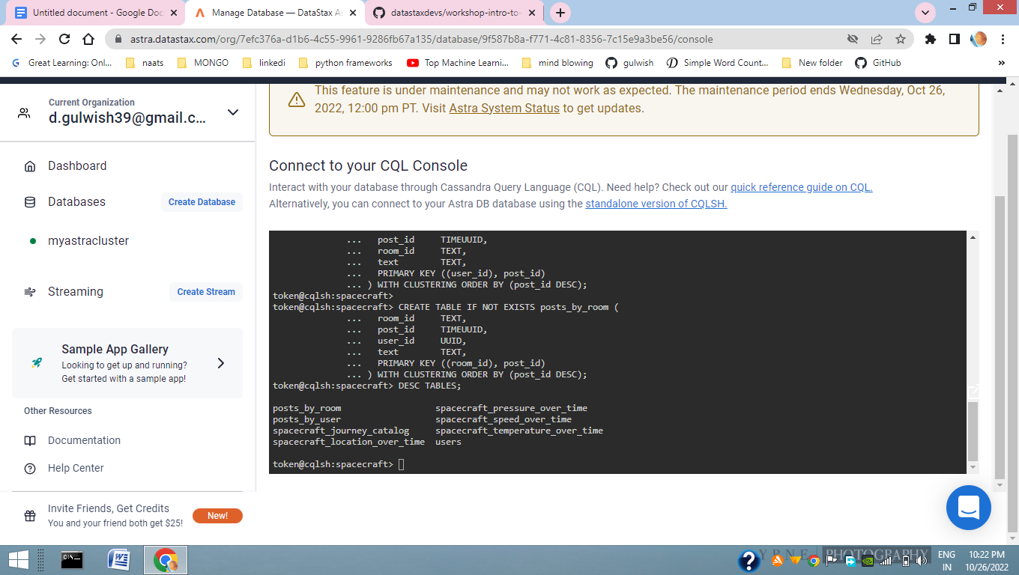

## **3. Execute CRUD operations**

// Read all rows from "posts_by_user" table (careful with this ...)

SELECT * FROM posts_by_user;

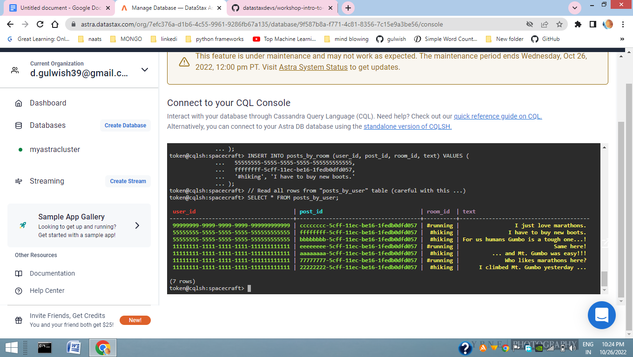

// Read (some columns of) rows in a certain partition of "posts_by_user" table

SELECT post_id, room_id, text FROM posts_by_user

WHERE user_id = 11111111-1111-1111-1111-111111111111;

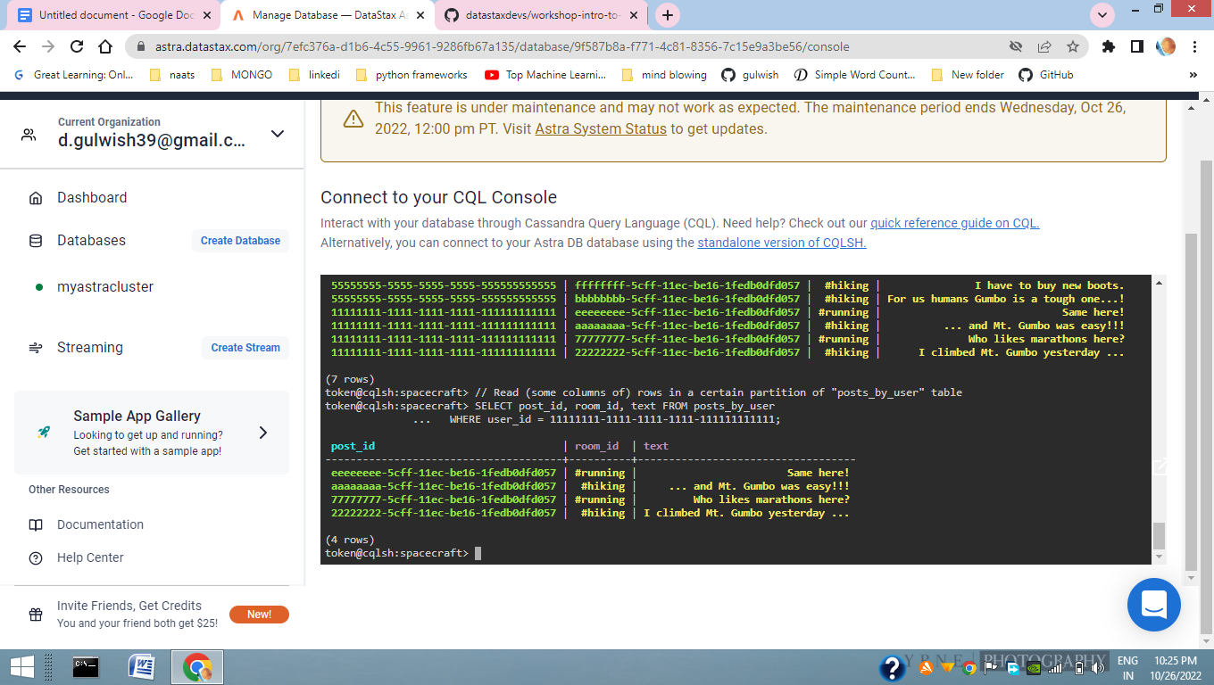

// Read the whole "posts_by_room" table

// (warning: not suitable for large tables in production)

SELECT * FROM posts_by_room;

// Read (some columns of) posts from a certain room (= a certain partition)

SELECT user_id, text FROM posts_by_room WHERE room_id = '#hiking';

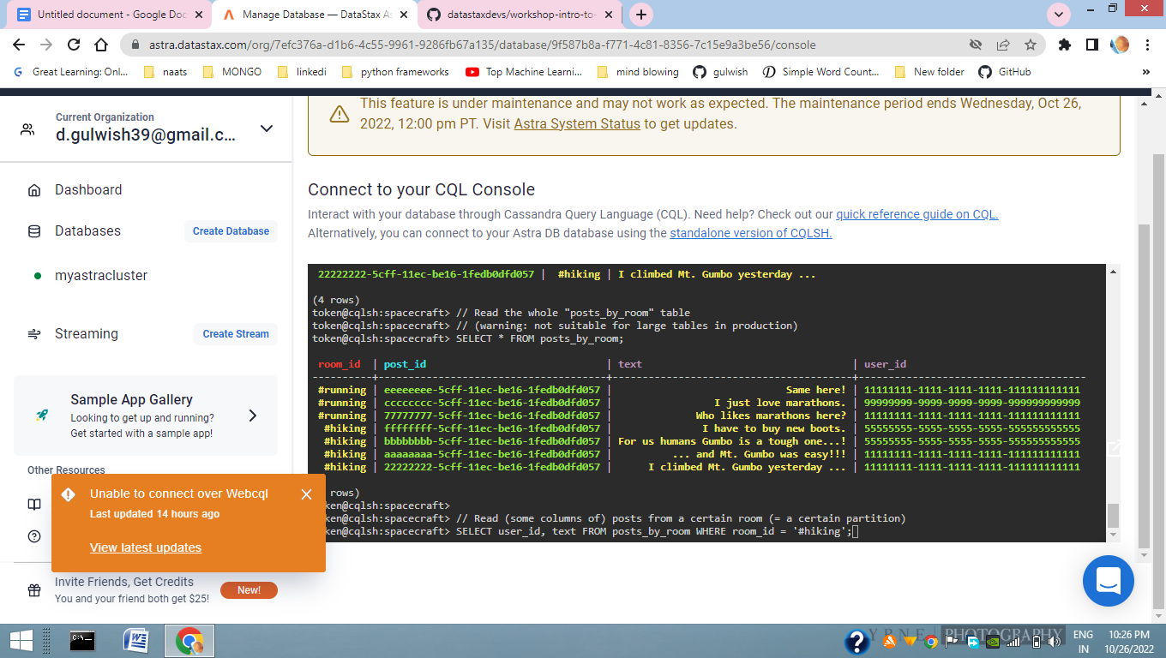

**UPDATE :**

UPDATE posts_by_user

SET text = '... and Mt. Gumbo was NOT SO easy!!!'

WHERE user_id = 11111111-1111-1111-1111-111111111111

AND post_id = aaaaaaaa-5cff-11ec-be16-1fedb0dfd057;

SELECT post_id, room_id, text FROM posts_by_user

WHERE user_id = 11111111-1111-1111-1111-111111111111;

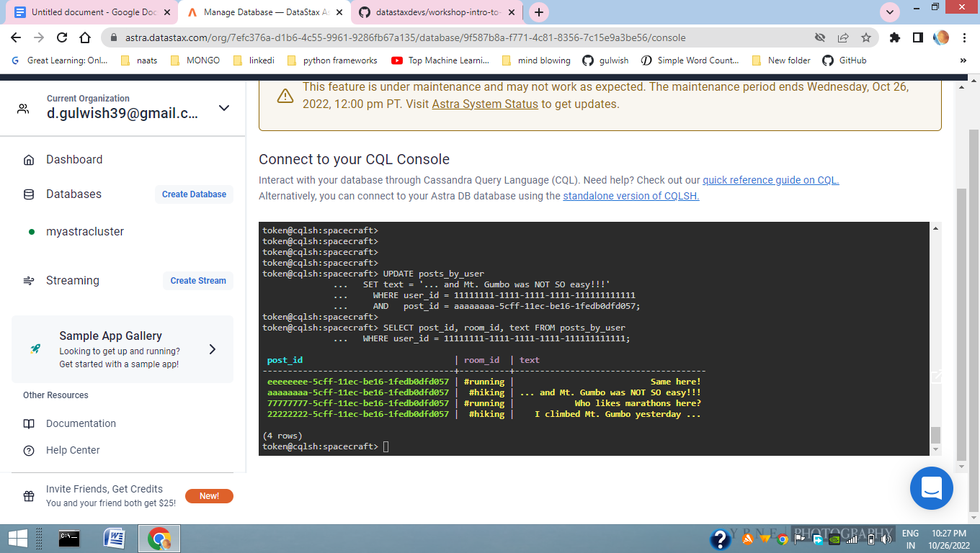

**step 3e. CRU(D) = delete = remove data**

|  |  |
| --- | --- |

DELETE FROM posts_by_user

WHERE user_id = 55555555-5555-5555-5555-555555555555

AND post_id = bbbbbbbb-5cff-11ec-be16-1fedb0dfd057;

DELETE FROM posts_by_room

WHERE room_id = '#hiking'

AND post_id = bbbbbbbb-5cff-11ec-be16-1fedb0dfd057;

SELECT post_id, room_id, text FROM posts_by_user

WHERE user_id = 55555555-5555-5555-5555-555555555555;

SELECT post_id, user_id, text FROM posts_by_room WHERE room_id = '#hiking';

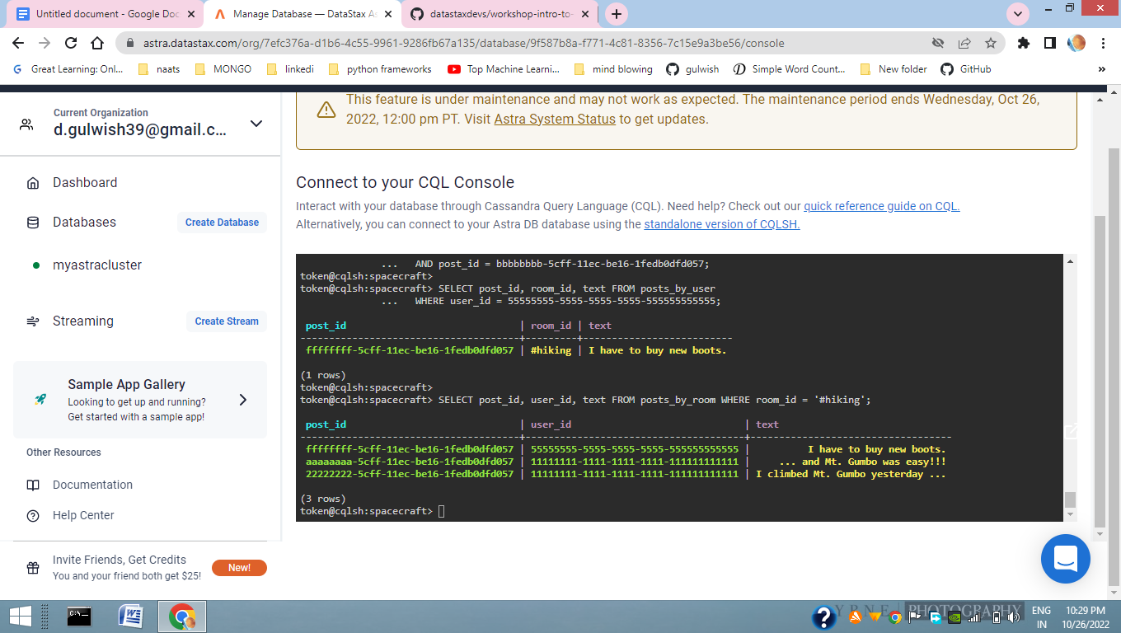

1. Reference link :<https://www.youtube.com/watch?v=3KsR59Y2_Uw>
2. https://github.com/datastaxdevs/workshop-intro-to-cassandra#1-create-your-astra-db-instance